Fishery & Habitat Grants: Project Examples
Creation & Restoration of Backwater Habitats
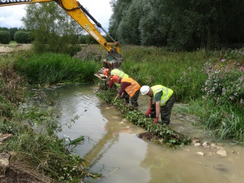
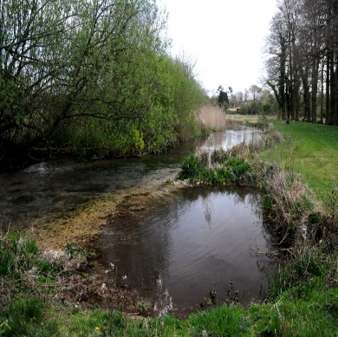
Where: existing channels, cut off meanders, ox bows, flood swales and new channels where environmental permitting allows.
Benefits:
- Refuge for juvenile fish during high flow events
- Provides opportunities to create suitable spawning habitat.
- Increases the ecological diversity of fish, amphibian, invertebrate and insect species
Gravel Cleaning
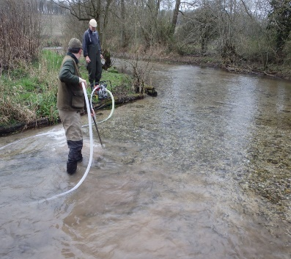
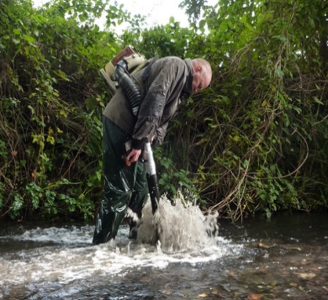
Where: Shallow riffels and glides.
Benefits:
- Increases suitable spawning habitat for species such as chub, barbel, dace and wild brown trout through the removal of silt and the effects of concretion from spawning gravels.
- Promotes the growth of macrophytes such as Ranunculus sp.
Woody Debris
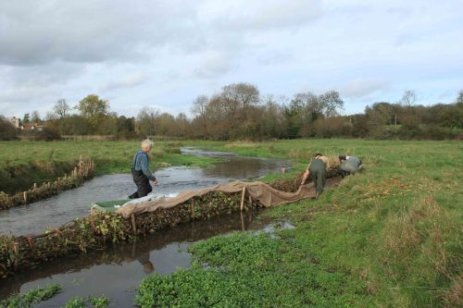
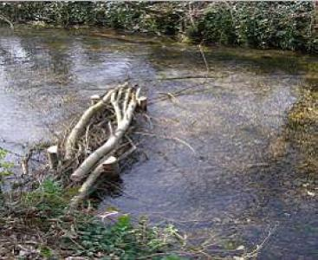
Where: Woody debris is valuable througout a river system where environmental permitting allows.
Benefits:
- Provides food and shelter for a range of fish & invertebrate species.
- Provides protection to banks from erosion.
- Provides channel, stream bed and flow diversity.
Planting a Buffer Zone
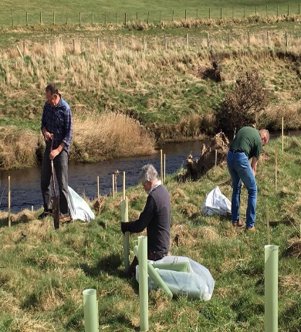
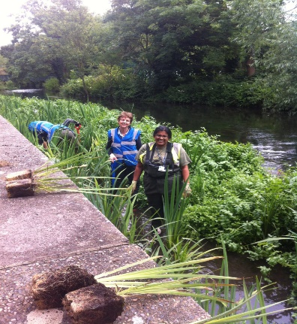
Where: Watercourses exposed to the influences of agriculture and urbanisation. Areas requiring bank stabilisation.
Benefits:
Provides new habitat, cover and shading for fish, invertebrate and insect species.
Provides stability to exposed and eroding banks.
- Acts as a filter for for the capture of nutrients, pollutants and sediment.
Managing Erosion
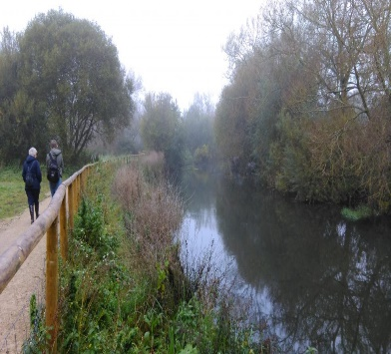
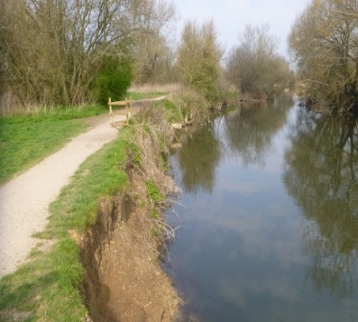
Where: Areas exposed to erosion attributable to natural occurrences and human activity.
Benefits:
- Reduces habitat degradtion and improves water quality and macrophyte growth by reducing sediment flow into watercourses.
- Maintains safe access to the river bank for anglers and recreational users.
Increasing Angling Participation: Physical Access
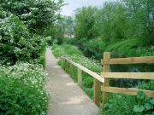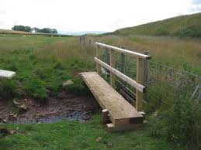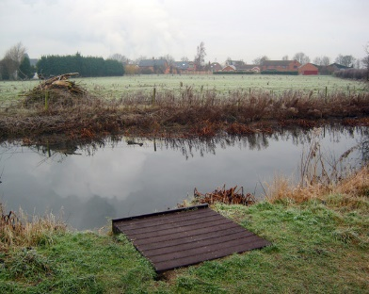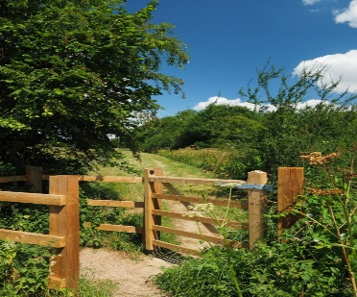
Where: Areas where new or updated infrastructure will provide greater or safer access for anglers & recreational users.
Benefits:
- Provides increased participation opportunities for a wider range of people of differing age and physical ability.
Increasing Angling Participation: Engagement
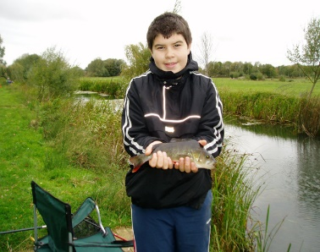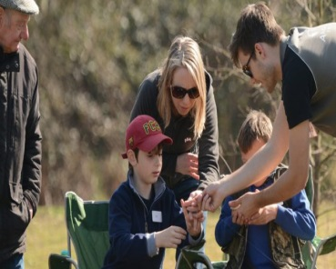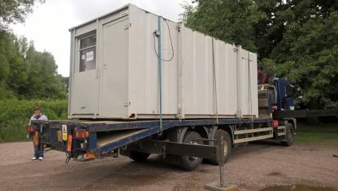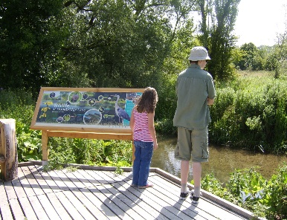
Where: Possible areas to increase angling participation include; providing facilities, equipment and coaching expertise suitable for all, engaging with local community and common interest groups to identify mutually beneficial projects and events and hosting public access events such as “taster days”, river walks and volunteer days.
Benefits:
- Can increase both short and long- term membership and volunteer uptake.
- It promotes a greater public awareness of river environments and ecology and the current pressures and issues.
- Mutually beneficial relationships with community and common interest groups can provide greater access to future funding and allows the development of strategies to benefit the wider riverine environment.

